DECLARATION

We hereby declare that the project work entitled “Home Rentals”- submitted to University of Kerala in the partial fulfilment of the requirements for the award of B. Sc Computer Science is a record of original work submitted under the guidance of Mrs Ragini. Department of Computer Science, National College during our period of study in National College, Thiruvananthapuram.

We also declare that this project has not been submitted to any other University or institution for the award of any degree or diploma.

Place: Thiruvananthapuram

Date:

## ACKNOWLEDGEMENT

First and for most, we convey our reverential salutation to the almighty for keeping us fit for the successful completion of this project. In the same note, we are also thankful to our parents for their help and moral support.

We are extremely thankful and profound our deepest gratitude to our respected principal Dr. Abdul Rahim. M sir for his guidance, motivation, encouragement and given to us throughout the course.

We express our deep sense of gratitude to Miss. Allwin. D, Head of Computer Science department and Mrs. Ragini, our guide for her keen interest, kind advice, valuable guidance, suggestions and encouragement throughout the making of the project. We sincerely thank all the faculty members of the Computer Science department for their valuable suggestions and inspiration.

Last but not the least, we would like to convey our gratitude to all our friends and classmates in supporting us for this project to make it true.

## ABSTRACT

This project aims at providing the users with a quick and safe way to both reserve and rent out rooms for a suitable price. You can sign up as a guest looking to rent a room for a few days, or a host who can rent out rooms, apartments, etc. and provide a hospitable experience while making money.

## Existing System

While there are websites to book hotels, there are none to rent out your own rooms as an independent user. This is usually in the hands of specialized businesses and hotel companies.

## Proposed System

This project looks at a simple and efficient way to both make reservations and rent out your own rooms and to provide a safe platform between the host and the guest. Where previously only big hotels and companies could advertise their rooms and facilities, now any person who signs up on our website can present and promote their rooms, facilities and other services. A main feature is the ability to set your location through Google maps which is integrated in our website.

## SYSTEM ANALYSIS AND DESIGN

System analysis is a detailed study of various operations performed by a system and their relationship within and outside of the system. One aspect of analysis is defining the boundaries of a system and determining whether or not the candidate system should consider other related systems. Analysis begins when a user or manager begins a study of the program using the existing system.

During analysis, data is collected on the various files, decision points and transactions handled by the present system. The commonly used tools in system analysis are dataflow diagram, interviews, onsite observation etc. System analysis is application of the system approach to the problem solving using computers. The ingredients are system elements, process and technology. This means that to do system work, one is to understand the system concepts and how the organizations operate as a system and the design appropriate computer based system that will meet the organizations requirements. It is actually customized approach to the use of computer problem solving.

Analysis can be defined as the separation of a substance into parts for study an interpretation, detailed examination. System development revolves around a lifecycle that begins with the recognition of user needs. The critical phase of managing a system project is planning. To launch a system investigation, we need a master plan detailing the steps taken, the people to be questioned and outcome expected.

System study or system analysis is the first among the four life cycle phase of a system. System study begins when a user or manager requests a studying of a program in either an existing or a project one. It involves studying the base of the organizations currently operating retrieving and processing data to produce information with the goal of determining how to make it work better, System analysis itself breaks down into stages-Preliminary and Detailed. During preliminary analysis the analyst and the user list the objectives of the system. The purpose of the preliminary investigation is to determine whether the problem or deficiency in the current system really exists. The project team may reexamine some of the feasibility aspects of the project. At this point, the purpose is to make a “go” or “no-go” decision. The end result is a decision to proceed further or to abandon the project.

Systems Analysis Process Map

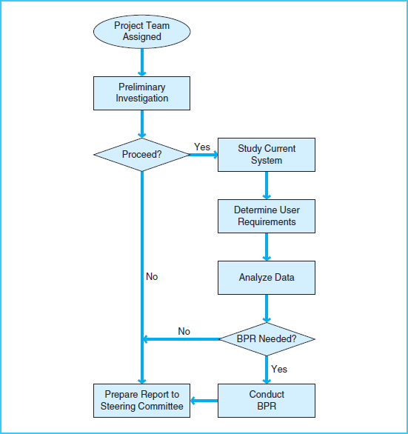

### Inputs to System Design

System design takes the following inputs −

* Statement of work
* Requirement determination plan
* Current situation analysis
* Proposed system requirements including a conceptual data model, modified DFDs, and Metadata (data about data).

### Outputs for System Design

System design gives the following outputs −

* Infrastructure and organizational changes for the proposed system.
* A data schema, often a relational schema.
* Metadata to define the tables/files and columns/data-items.
* A function hierarchy diagram or web page map that graphically describes the program structure.
* Actual or pseudocode for each module in the program.
* A prototype for the proposed system.

**FEASIBLITY STUDY**

Feasibility Study in Software Engineering is a study to evaluate feasibility of proposed project or system. Feasibility study is one of stage among important four stages of Software Project Management Process. As name suggests feasibility study is a measure of the software product in terms of how much beneficial product development will be for the organization in a practical point of view. Feasibility study is carried out based on many purposes to analyze whether software product will be right in terms of development, implantation, contribution of project to the organization

Types of Feasibility Study :

The feasibility study mainly concentrates on below five mentioned areas. Among these Economic Feasibility Study is most important part of the feasibility analysis and Legal Feasibility Study is the least important

* Technical Feasibility
* Operational Feasibility
* Economic Feasibility

1. Technical Feasibility –

In Technical Feasibility current resources both hardware software along with required technology are analyzed/assessed to develop project. This technical feasibility study gives report whether there exists correct required resources and technologies which will be used for project development. Along with this, feasibility study also analyzes technical skills and capabilities of technical team, existing technology can be used or not, maintenance and up-gradation is easy or not for chosen technology etc.

1. Operational Feasibility –

In Operational Feasibility degree of providing service to requirements is analyzed along with how much easy product will be to operate and maintenance after deployment. Along with this other operational scopes are determining usability of product, Determining suggested solution by software development team is acceptable or not etc.

1. Economic Feasibility –

In Economic Feasibility study cost and benefit of the project is analyzed. Means under this feasibility study a detail analysis is carried out what will be cost of the project for development which includes all required cost for final development like hardware and software resource required, design and development cost and operational cost and so on. After that it is analyzed whether project will be beneficial in terms of finance for organization or not.

Need of Feasibility Study :

Feasibility study is so important stage of Software Project Management Process as after completion of feasibility study it gives a conclusion of whether to go ahead with proposed project as it is practically feasible or to stop proposed project here as it is not right/feasible to develop or to think/analyze about proposed project again.

Along with this Feasibility study helps in identifying risk factors involved in developing and deploying system and planning for risk analysis also narrows the business alternatives and enhance success rate analyzing different parameters associated with proposed project development.

## Hardware Specifications

|  |  |  |  |
| --- | --- | --- | --- |
|  | **Windows requirements** | **Mac requirements** | **Linux requirements** |
| **Operating system** | Windows 8 or later | macOS Sierra 10.12 or later | 64-bit Ubuntu 14.04+, |
| **Processor** | Intel Pentium 4 or later | | |
| **Memory** | 2 GB minimum, 4 GB recommended | | |
| **Screen resolution** | 1280x1024 or larger | | |
| **Internet connection** | Required | | |
|  |  | | |

## Software Specifications

|  |  |
| --- | --- |
| **Server** | XAMPP |
| **Database** | MySQL |
| **Editor** | NetBeans |
| **Web Browsers** | Chrome, Mozilla |
| **Javascript libraries:** | jQuery, Angular js |
| **Languages:** | HTML, PHP, Javascript |

System Design

## Registration

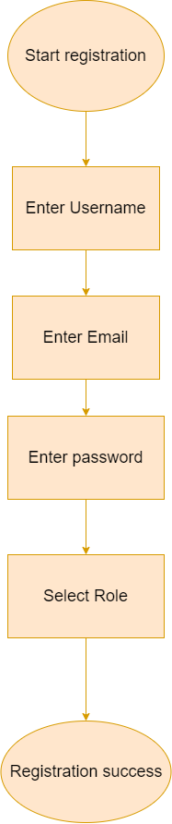

## Login

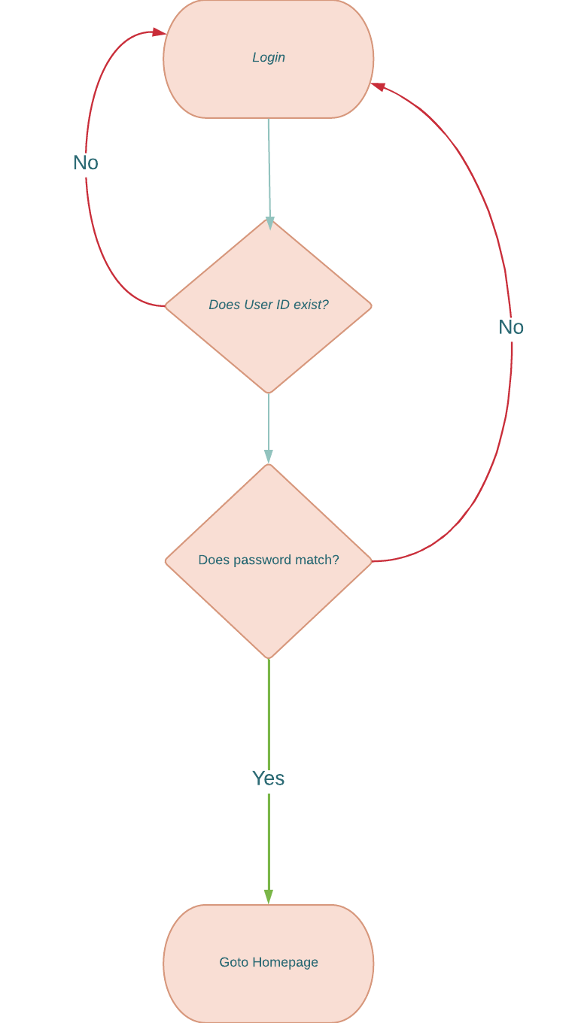

## TABLES

## REGISTRATION DETAILS

|  |  |  |
| --- | --- | --- |
| Name | Type | Attribute |
| User ID | INT | PRIMARY KEY |
| User Name | VARCHAR |  |
| User Email | VARCHAR |  |
| User Password | VARCHAR |  |
| User Role | VARCHAR |  |

## RENTALS DETAILS

|  |  |  |
| --- | --- | --- |
| Name | Type | Attributes |
| Rent ID | INT | PRIMARY KEY |
| Host ID | INT | FOREIGN KEY |
| Location Name | VARCHAR |  |
| Location Images | IMAGE |  |
| Location Details | VARCHAR |  |
| Location Price | VARCHAR |  |
| Location Summary | VARCHAR |  |
| Location Rules | VARCHAR |  |
| Location Address | VARCHAR |  |
| Location Map Coordinates | VARCHAR | FOREIGN KEY |

## CART DETAILS

|  |  |  |
| --- | --- | --- |
| Name | Type | Attributes |
| Cart ID | INT | PRIMARY KEY |
| User ID | INT | FOREIGN KEY |
| Rent ID | INT | FOREIGN KEY |

## HOST DETAILS

|  |  |  |
| --- | --- | --- |
| Name | Type | Attributes |
| Profile ID | INT | PRIMARY KEY |
| Host ID | INT | FOREIGN KEY |
| Host Name | VARCHAR |  |
| About Host | VARCHAR |  |
| Host Details | VARCHAR |  |
| Host Email | VARCHAR |  |
| Host Phone Number | VARCHAR |  |
| Other Host Contacts | VARCHAR |  |

## FEEDBACK AND COMMENTS ON RENTALS

|  |  |  |
| --- | --- | --- |
| Name | Type | Attributes |
| ID | INT | PRIMARY KEY |
| Rent ID | INT | FOREIGN KEY |
| Customer Name | VARCHAR |  |
| Feedback | VARCHAR |  |
| Rating | INT |  |
|  |  |  |
|  |  |  |
|  |  |  |